**Association of Southeast Asian Nations (ASEAN)**

The Association of Southeast Asian Nations (ASEAN) is a regional grouping that promotes economic, political, and security cooperation among its ten members: Brunei, Cambodia, Indonesia, Laos, Malaysia, Myanmar, the Philippines, Singapore, Thailand, and Vietnam. ASEAN countries have a population of more than[622 million people (PDF)](http://www.asean.org/wp-content/uploads/2015/12/AEC-at-a-Glance-2015.pdf)and a combined GDP of $2.6 trillion, according to 2014 figures. The group has spurred economic integration, signing six[free-trade agreements](http://asean.org/asean-economic-community/free-trade-agreements-with-dialogue-partners/) with other regional economies. Yet experts say ASEAN’s impact is limited by a lack of strategic vision, diverging national priorities, and weak leadership. The bloc’s biggest challenge is negotiating a unified approach to China, particularly in response to its widespread maritime claims in the South China Sea. The United States sees ASEAN as vital to the success of its strategic rebalance to Asia.

ASEAN: Then and Now

ASEAN is chaired by an annually rotating presidency assisted by a[secretariat](http://asean.org/asean/asean-secretariat/) based in Jakarta, Indonesia. Decisions are reached through consultation and consensus guided by the principles of noninterference in internal affairs and the peaceful resolution of conflicts. Some experts see this approach to decision-making as a chief drawback for the organization. “The emphasis on consensus, not losing face, and voluntarism has meant that the[politics of the lowest common denominator (PDF)](http://journals.sub.uni-hamburg.de/giga/files/journals/4/articles/931/public/931-967-1-PB.pdf) has tended to prevail, and difficult problems have been avoided rather than confronted,” writes Mark Beeson, professor of international politics at the University of Western Australia, Perth in a 2016 journal article.

Other experts say ASEAN has contributed to regional stability by building much-needed norms and fostering a neutral[environment](https://www.munplanet.com/articles/international-relations/aseans-strength-and-continued-relevance-in-asia-pacific) to address shared challenges. “In Asia, talking and relationship building is half the challenge to solving problems,” says Murray Hiebert, senior advisor and deputy director of the Southeast Asia Program at the Washington-based Center for Strategic and International Studies.

Formed in 1967, ASEAN united Indonesia, Malaysia, the Philippines, Singapore, and Thailand in an effort to reduce regional hostilities and to fight the potential threat of communist-led insurgencies at the height of the U.S. war in Vietnam. The five founding members sought a community to promote political and social stability amid rising tensions among the Asia-Pacific's post-colonial states. In 1976, the members signed the [Treaty of Amity and Cooperation](http://asean.org/treaty-amity-cooperation-southeast-asia-indonesia-24-february-1976/), emphasizing ASEAN's promotion of peace, friendship, and cooperation to build solidarity.

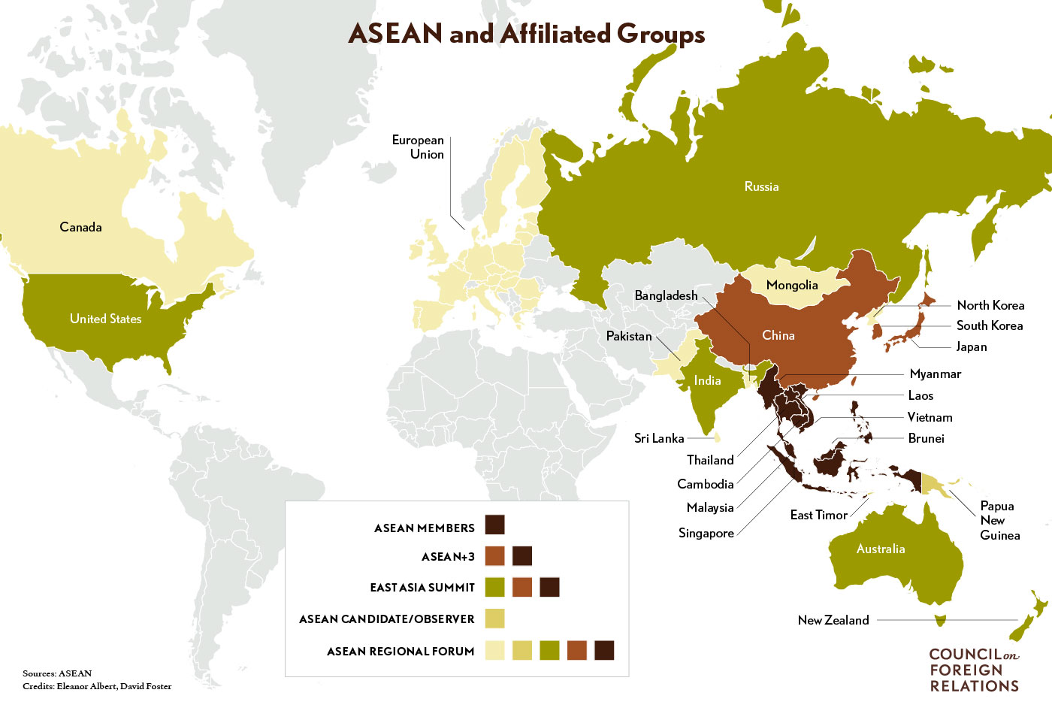

Membership doubled by the early 1990s, boosted in part by changing conditions following the end of the Vietnam War in 1975 and the Cold War in 1991. With the addition of Brunei (1984), Vietnam (1995), Laos and Myanmar (1997), and Cambodia (1999), the group started to launch initiatives to boost regionalism. The members signed a deal in 1995 to create a[nuclear-free zone](http://asean.org/?static_post=treaty-on-the-southeast-asia-nuclear-weapon-free-zone) in Southeast Asia, committing to refrain from the use of nuclear weapons, including on land and in maritime territories.

Faced with the 1997 Asian financial crisis, ASEAN members moved to integrate their economies to mitigate future economic turmoil. The[Chiang Mai Initiative (PDF)](http://www.bsp.gov.ph/downloads/publications/faqs/cmim.pdf), for example, was an agreement among ASEAN and China, Japan, and South Korea to provide financial support through currency swaps. ASEAN states also signed a declaration in the aftermath of the 9/11 attacks in the United States to bolster national and regional mechanisms and increase information sharing.

In 2007, the ten members adopted the[ASEAN Charter (PDF)](http://www.asean.org/wp-content/uploads/2012/05/11.-October-2015-The-ASEAN-Charter-18th-Reprint-Amended-updated-on-05_-April-2016-IJP.pdf), a constitutional document, providing the grouping with legal status and revamping its institutions. The charter enshrines core ASEAN principles and delineates requirements for membership. The charter also originally included provisions for sanctions and a system to monitor compliance of ASEAN agreements, but those were dropped amid internal objections.

*“In Asia, talking and relationship building is half the challenge to solving problems,”—Murray Hiebert, senior advisor and deputy director of the Southeast Asia Program , Center for Strategic and International Studies*

The charter set out a blueprint for a community built on three branches: the ASEAN [Economic Community](http://asean.org/asean-economic-community/) (AEC), the ASEAN[Political-Security Community](http://asean.org/asean-political-security-community/), and the ASEAN [Socio-Cultural Community](http://asean.org/asean-socio-cultural/). Developments on the economic front have borne the most fruit; in 2016, the AEC’s inaugural year, the bloc’s economy is expected to grow by 5.3 percent, according to the[Asian Development Bank (PDF)](http://www.adb.org/sites/default/files/publication/154508/ado-2015.pdf). The AEC’s [four pillars (PDF)](http://www.asean.org/wp-content/uploads/images/archive/5187-10.pdf)are: the creation of a single market with the free flow of goods, services, investment, and skilled labor; fair economic competition; sustainable and equitable economic development; and further integrating ASEAN into the global economy. Yet some of the regions are not covered by preferential trade measures, and the income inequality gap among ASEAN members could make economic integration more.

Still, some experts see the AEC as a potential catalyst for intensifying economic integration. “The ASEAN economic community is a major project. Its realization will radically change the region's economic and political landscape. The challenges are equally great,” said Hadi Soesastro, executive director of the Centre for Strategic and International Studies, Jakarta, in 2007 when plans for the economic community were adopted.

Since the start of the ASEAN free trade area in 1993, intra-ASEAN trade has grown from[19.2 percent (PDF)](http://www.asean.org/storage/images/ASEAN_RTK_2014/ACIF_Special_Edition_2014.pdf) to[24 percent (PDF)](http://asean.org/storage/2015/12/table18_as-of-10-June-2016.pdf) in 2015. Across the grouping, more than 90 percent of goods are traded with [no tariffs (PDF)](http://www.asean.org/wp-content/uploads/images/2015/November/aec-page/AEC-2015-Progress-and-Key-Achievements.pdf). The grouping has also prioritized eleven in goods and services for integration, including electronics, automotives, rubber-based products, textiles and apparels, agro-based products, and tourism. ASEAN members have made strong efforts to facilitate trade, says Hiebert, but challenges remain.

ASEAN and Regional Security

ASEAN security challenges include border disputes, human trafficking, natural and manmade disasters, food security, and cross-border terrorism and insurgencies. The vast majority of regional security issues are dealt with through ASEAN or the following ASEAN-led forums:

* **ASEAN Regional Forum (ARF)**: Launched in 1993, the twenty-seven-member multilateral grouping was developed to facilitate cooperation on political and security issues to contribute to regional confidence-building and preventive diplomacy. The forum represents a wide array of voices—including ASEAN, its dialogue partners, North Korea, and Pakistan, among others—yet it is often mired in geopolitical disputes that limit its effectiveness.
* **ASEAN Plus Three**: The [consultative group](http://asean.org/?static_post=asean-plus-three-cooperation-2) initiated in 1997 brings together ASEAN’s ten members, China, Japan, and South Korea. The grouping was characterized as “the [most coherent and substantive](http://www.cfr.org/asia-and-pacific/united-states-new-asia/p20446) pan-Asian grouping” by Evan A. Feigenbaum and Robert A. Manning in a CFR report.
* **East Asia Summit (EAS)**: First held in 2005, the summit seeks to promote security and prosperity in the region and is attended by the heads of state from ASEAN, Australia, China, India, Japan, New Zealand, Russia, South Korea, and the United States. ASEAN plays a central role as the [agenda-setter](http://www.nbr.org/research/activity.aspx?id=183). Washington sees the summit as the “[go-to forum](http://www.state.gov/p/eap/rls/rm/2015/12/250315.htm)” for addressing security and political issues in Asia-Pacific, according to 2015 testimony by Michael Fuchs, former U.S. Deputy Assistant Secretary of State for the East Asian and Pacific Affairs bureau. Despite the prevalence of diplomatic forums, disagreements on security issues haunt ASEAN unity. Its most glaring challenge is finding a joint response to the rise of China. “China’s re-emergence as the major power in the East Asia region is not only likely to transform Southeast Asia’s relations with China, but also perhaps the[internal relations of ASEAN itself (PDF)](http://journals.sub.uni-hamburg.de/giga/files/journals/4/articles/931/public/931-967-1-PB.pdf),” writes Beeson, of the University of Western Australia.

Maritime disputes in the South China Sea have been the biggest irritant among ASEAN members. Brunei, Malaysia, the Philippines, and Vietnam share overlapping claims to features in contested waters with China. For them, China’s moves to reclaim land and to build artificial islands are threatening and seen as violations of national sovereignty. For other members, like Cambodia, the tension in the South China Sea is geographically distant and not as relevant. In the absence of consensus, efforts to make the [Declaration of Conduct of Parties in the South China Sea](http://asean.org/?static_post=declaration-on-the-conduct-of-parties-in-the-south-china-sea-2) between ASEAN and Beijing into a binding code of conduct have been futile. In response, a number of claimants have appealed for greater U.S. support. The United States has responded by stepping up military cooperation with ASEAN members like the [Philippines](http://www.cfr.org/philippines/us-philippines-defense-alliance/p38101) and [Vietnam](http://thediplomat.com/2016/06/us-arms-sales-to-vietnam-a-military-analysis/) and heightening its maritime presence to enforce [freedom of navigation](https://amti.csis.org/fonops-primer/) in international waters. At the same time, Southeast Asian nations have also [invested](http://www.bloomberg.com/news/articles/2016-03-24/arms-spending-spree-in-southeast-asia-has-singapore-worried) in modernizing their militaries.

ASEAN members have been divided by their ties with China and the United States. The region overall is in need of investment, trade, and particularly infrastructure development and China has moved to fill these needs. But ASEAN members are anxious of becoming over reliant and dependent on China; in turn, these nations “look to the United States to hedge,” says CSIS’ Hiebert.

*“The emphasis on consensus, not losing face, and voluntarism has meant that difficult problems have been avoided rather than confronted.”—Mark Beeson, professor of international politics at the University of Western Australia, Perth*

Boosting U.S.-ASEAN Ties

The United States is ASEAN’s third largest trading partner, after China ($346 billion) and Japan ($239 billion) respectively, with trade between the two sides reaching more than[$212 billion (PDF)](http://asean.org/storage/2015/12/table20_as-of-10-June-2016.pdf) in 2015. This accounts for approximately 9 percent of ASEAN's total trade. The United States also has launched sub-regional and bilateral initiatives to boost ties with Southeast Asia, including the [Lower Mekong Initiative](http://www.state.gov/p/eap/mekong/) to deepen cooperation between the United States and ASEAN members Cambodia, Laos, Myanmar, Thailand, and Vietnam on issues related to the environment, health, education, and infrastructure development. Four ASEAN members (Brunei, Malaysia, Singapore, and Vietnam) have also joined the U.S.-led [Trans-Pacific Partnership](http://www.cfr.org/trade/future-us-trade-policy/p36422), a free trade agreement among twelve nations.

President Barack Obama’s administration, as part of its rebalance, has also increased U.S. participation in ASEAN activities, including sending top-level officials to regional summits, naming a resident ambassador to ASEAN, joining the Treaty of Amity and Cooperation, and establishing a U.S.-ASEAN annual summit. In November 2015, U.S. and ASEAN leaders elevated their relationship to a strategic partnership, followed by the first [standalone summit](https://www.whitehouse.gov/the-press-office/2016/02/16/joint-statement-us-asean-special-leaders-summit-sunnylands-declaration) between heads of state and government from the United States and ASEAN members in February 2016 in Sunnylands, California.

At an August 2016 summit with Singapore's prime minister, Obama said “much of our work in the Asia Pacific region is not a matter of active conflict, but rather [creating an architecture](https://www.whitehouse.gov/the-press-office/2016/08/02/remarks-president-obama-and-prime-minister-lee-singapore-joint-press), a framework of rules and norms that keeps the peace and that has underwritten security for the region and for us for many years now.” CFR Senior Fellow for Southeast Asia Joshua Kurlantzick says that at the very least, Washington has embraced the [importance of symbolism](http://blogs.cfr.org/asia/2016/02/19/the-u-s-asean-summit-final-thoughts/) within ASEAN. Yet some experts say the U.S. failure to [ratify the TPP](https://www.whitehouse.gov/the-press-office/2016/08/02/remarks-president-obama-and-prime-minister-lee-singapore-joint-press) and an insufficient U.S. commitment to Southeast Asia prolongs ASEAN concerns of regional instability. “The U.S. faces a [crucial test of its reliability](http://asia.nikkei.com/Viewpoints/Viewpoints/Patrick-Cronin-and-Derwin-Pereira-The-East-Asia-Summit-and-Obama-s-Asia-legacy?page=2) in Southeast Asia,” write Patrick Cronin of the Center for a New American Security and Derwin Pereira of a Singapore-based political consultancy.

Disunity and Relevance

ASEAN brings together neighbors with varying economic, political, and social systems. Singapore boasts the highest GDP per capita with more than $52,000 based on 2015 World Bank figures, while Cambodia’s per capita GDP is a meager $1,159. The members’ political systems are equally mixed with democracies, communist, and authoritarian states. Demographics vary across the region, too; some countries are sparsely populated, others are densely populated with range of dominant religious groups. Geographically, ASEAN is a grouping of archipelago nations, as well as continental land masses with low plains and mountainous terrain. Such diversity means that full agreement on any single issue can seem insurmountable.

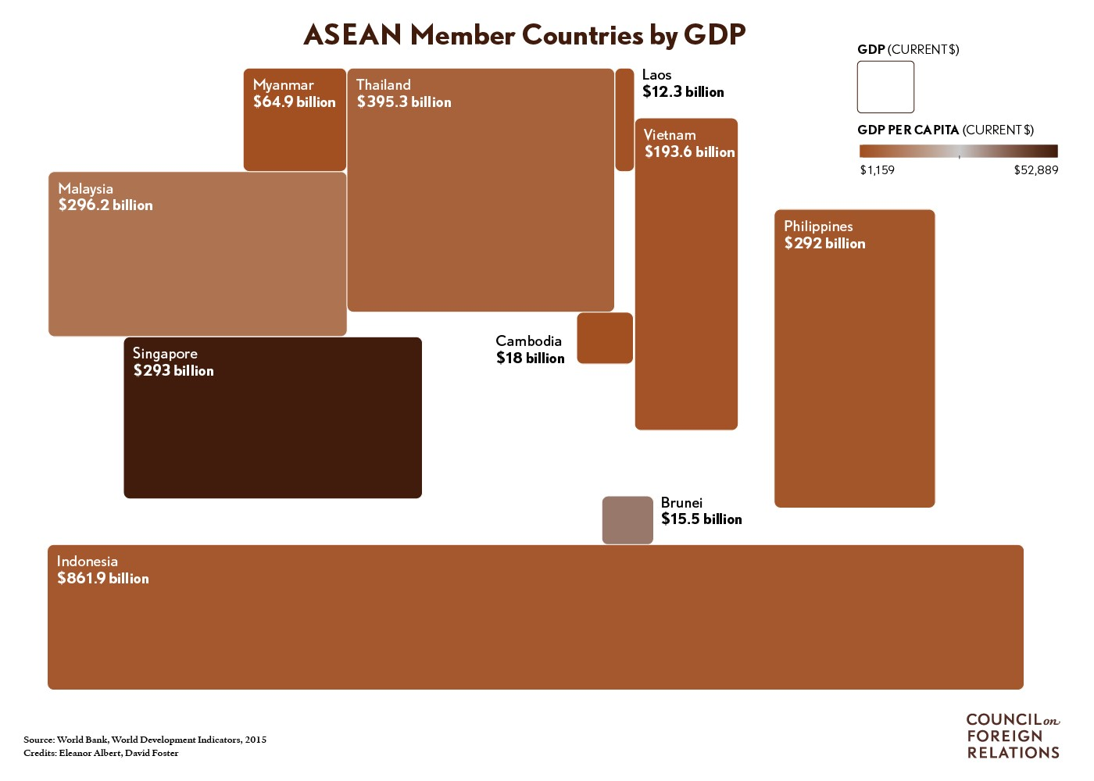

While the South China Sea is the main issue exposing the organization’s rifts, progress has also faltered on other important fronts, like [human rights](https://www.hrw.org/news/2016/02/10/human-rights-shouldnt-be-sidelined-asean-summit). For example, ASEAN has been divided over addressing repression in member states like Cambodia, and waves of migration, like that of the [Rohingya refugee crisis](http://www.cfr.org/burmamyanmar/rohingya-migrant-crisis/p36651).

Some experts have suggested that ASEAN reimagine its framework and decision-making practices. In 2012, Kurlantzick recommended [substantive changes](http://www.cfr.org/asia-and-pacific/aseans-future-asian-integration/p29247) to enable the organization to lead integration efforts in Asia. These included strengthening its secretariat and empowering a high-profile secretary-general to speak on its behalf; abandoning consensus decision making, and demonstrating that ASEAN can build its own free trade area. Others, like CSIS’ Hiebert, see the organization taking on a coalition-of-the-willing format in which some of the group's members decide to act on certain issues, like [joint maritime patrol initiatives](http://www.thejakartapost.com/news/2016/08/02/indonesia-to-start-joint-sea-patrols-with-malaysia-philippines.html) currently underway, while others will join later once they are ready.

**Additional Resources**

CFR’s Joshua Kurlantzick analyzes overall U.S. security aid to Southeast Asia during the Obama administration's rebalance to Asia in this 2016 [Interactive](http://www.cfr.org/asia-and-pacific/rebalance-asia/p37516/?cid=otr-marketing_use-rebalancetoasia#!/?cid=otr-marketing_use-rebalancetoasia).

Experts discuss the future of Asia’s regional institutions and multilateral mechanisms at an April 2015 [CFR Event](http://www.cfr.org/asia-and-pacific/bridging-cooperation-competition-asia/p36444) on the U.S. Rebalance to Asia.

Raman Letchumanan breaks down the [details of the ASEAN economic community](https://www.rsis.edu.sg/rsis-publication/nts/co15028-what-is-the-asean-community-2015/#.V8XQ3vkrKUk) in this February 2015 commentary.

The [ASEAN Charter (PDF)](http://www.asean.org/wp-content/uploads/2012/05/11.-October-2015-The-ASEAN-Charter-18th-Reprint-Amended-updated-on-05_-April-2016-IJP.pdf) outlines the purpose and objectives of the ten member multilateral grouping.